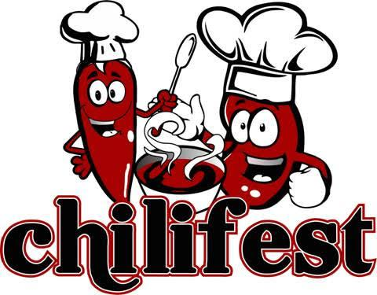
SPONSORSHIP OPPORTUNITIES

$1500 Raw Heat Extreme Hot Sauce Sponsor (1 Available)
• Your logo and link in event marketing; emails, social media posts, and website
• Your logo on the event photo banner
• Special DJ mention during the event
• 4 tickets to the event
• 4 drink vouchers
• Your logo on 400 water bottle labels
• Guest judge for Chili Cook Off

$1000 VooDoo Chile Bacon Hot Sauce Sponsor (1 Available)
• Your logo and link in event marketing; emails, social media posts, and website
• Your logo on the event photo banner
• Special DJ mention during the event
• 4 tickets to the event
• 4 drink vouchers
• Guest judge for Chili Cook Off

$750 Smack Your Face Hot Sauce Sponsor (2 Available)
• Your logo and link in event marketing; emails, social media posts, and website
• Your logo on the event photo banner
• Special DJ mention during the event
• 4 tickets to the event
• 4 drink vouchers

$500 Delicious Suffering Hot Sauce Sponsor (Unlimited Available)
• Your logo and link in event marketing; emails, social media posts and website
• Special DJ mention during the event
• 2 tickets to the event
• 2 drink vouchers

$250 Bad To The Bone Hot Sauce Sponsor (Unlimited Available)
• Your logo and link in event marketing; emails, social media posts and website
• 2 tickets to the event

If none of these levels or ideas fit with your business, please call us to brainstorm a sponsorship custom opportunity.

For more information, please visit our website at www.friendslhs.org. If you would like to participate please contact Sarah Ryan, Events Coordinator, at 443-569-4209 or email events@annapolislighthouse.org no later than February 10, 2019.
